**An Investigation of Gastrointestinal Stromal Tumors (GISTs)**

**And their Treatment Processes**

A THESIS

Presented to the Department of Mathematics and Computer Science

Texas Woman’s University

In Partial Fulfillment

of the Requirements for the Degree

Master of Science in Informatics

By Madison Tate

B.S., 2021, Texas Tech University

Under the Supervision of Professor Mark Mann, Ph.D.

May 2023

Researcher: Madison Tate

Presentation Title: An Investigation of Gastrointestinal Stromal Tumors (GISTs) and their Treatment Processes

Research Focus: Common locations, metastatic rates, sizes, and treatments for GISTs in relation to my father’s diagnosis of a GIST.

School: Texas Woman’s University

Student Level: Masters

**Abstract**

Gastrointestinal Stromal Tumors (GISTs), though considered rare in occurrence, are the most common sarcoma found within the digestive tract in the United States, with about 5,000 new cases diagnosed each year. This project aims to investigate exactly what GISTs are and their current treatment process, to promote an increase in research and awareness of this type of cancerous tumor. Additionally, the purpose of this thesis is to compare and contrast the current diagnosis and treatment tract of my own father’s GIST with my research findings. All information and data for all of the subsequent visualizations was collected by reading and analyzing already published academic journals from the website PubMed (accessed through Texas Woman’s University’s library database). Research indicates that GISTs may differ in- size, predominant cell type, genetic alteration, tumor location, and treatment process- making a definitive treatment plan and prognosis difficult to obtain. Further barriers to a treatment plan and prognosis include a lack of consensus amongst the medical community and a need for new alternative therapies for treatment due to an increase in patients’ growing biological resistance to current medicines. These findings showcase a need for additional research about and awareness for gastrointestinal stromal tumors within the United States.

1

**Introduction**

Originally, the purpose of my study was to research gastrointestinal stromal tumors (GISTs) to find out more about this type of tumor and the treatment track for individuals diagnosed with a GIST. The reason I chose this particular topic was because my father was diagnosed with a GIST a year ago, after a year and a half of diagnostic testing. I wanted to understand on a deeper level my father’s diagnosis and potential treatments he may undergo to be cured, to better prepare myself and my father for what was and is to come. Though, I would later be shocked by the lack of consensus within the national and international medical communities about how to treat a GIST.

Unlike with other potential topics of research, I unfortunately ran into a problem with my research. I was unable to find large, raw statistical data related to GISTs, where I could build more complex visualizations. Most of the data I was able to find for the infographics I ended up creating were confined to small tables, and did not feature a lot of quantitative data points. This, however, did not interfere with my original purpose, but instead provided me the opportunity to get more personal in my approach to the topic. I decided to compare and contrast the research I was able to find with my father’s specific case, in order to make my project stronger and more compelling for the audience, and I feel the visuals placed throughout this report assist in that endeavor.

Most individuals probably have never heard of a gastrointestinal stromal tumor before, unless they or someone they know has been diagnosed with a GIST. My father and I certainly had never heard of this type of tumor and cancer before his diagnosis over a year ago. GISTs are often subsequently found while patients are undergoing a routine procedure, and sometimes can even

2

be misdiagnosed as small asymptomatic lesions by health professionals. So, I decided to research exactly what GISTs are, how they develop, different treatment methods for GISTs, and general information about this particular tumor. The following report details my findings and how these findings relate to my father’s case.

**Materials and Methods**

To effectively research this topic, I analyzed numerous peer-reviewed articles from the online database PubMed, while making sure these articles included numeric data I could effectively translate into infographics. During my searching process, I happened to come across a flowchart that outlined a patient’s treatment course after being diagnosed with a GIST, though I would later have to shorten and reformat this flowchart for my purposes. I then decided to include my father’s diagnosis within my report by creating a flowchart documenting his own treatment process to make comparisons to the aforementioned found chart. Since my reason for choosing this thesis topic was personal in nature to begin with, I realized it was only right to include my father in my report and visualizations too.

All of the graphs for this report were created using the software application Visme. This application proved more beneficial for my project versus other applications due to its ability to create a variety of infographics, with easy to use features and several template options for different design options. Due to the articles I found and utilized not having any big datasets for me to manipulate and transfer over, I did not need to worry about Visme’s inability to handle the importing of large datasets and did not have to resort to using another program to do so. For the flowchart I created about my father’s treatment process after diagnosis and to edit the chart that already existed about patients’ treatment plans, I used the software program Draw.io through

3

Google. The program allowed me to build succinctly detailed, connective flowcharts through an easy drag and drop method, for a clean and simple design. Throughout the report, you should see clean, yet captivating, designs for all visuals, a skill I believe all informatics professionals should possess.

**Discussion**

**Locations, Histology, and the Immunochemistry of GISTs**

An article by Parab et al. called *Gastrointestinal Stromal Tumors: A Comprehensive Review* was one of the first articles I read when researching my topic. The 2018 article, originally published in the Journal of Gastrointestinal Oncology, discusses: what GISTs are, how GISTs are identified and categorized, a patient’s risk assessment after being diagnosed with a GIST, and different treatments options for a GIST, including new therapy options. In order to form a comprehensive assessment of GISTs for their article, Parab et al. read through numerous, already published articles and extracted common themes to form their own conclusions.

After establishing that “gastrointestinal stromal tumors (GISTs) are relatively rare neoplasms of the gastrointestinal tract,” Parab et al. decided to focus on the epidemiology of GISTs, in particular, where GISTs are commonly found within the gastrointestinal tract, (Parab et al., 2018). They found that GISTs were most commonly found in the stomach (56%), followed by the small bowel (32%), colon and rectum (6%), the esophagus (0.7%), and finally in other locations (5.5%), (Parab et al. , 2018). The below graphic showcases these findings.

4

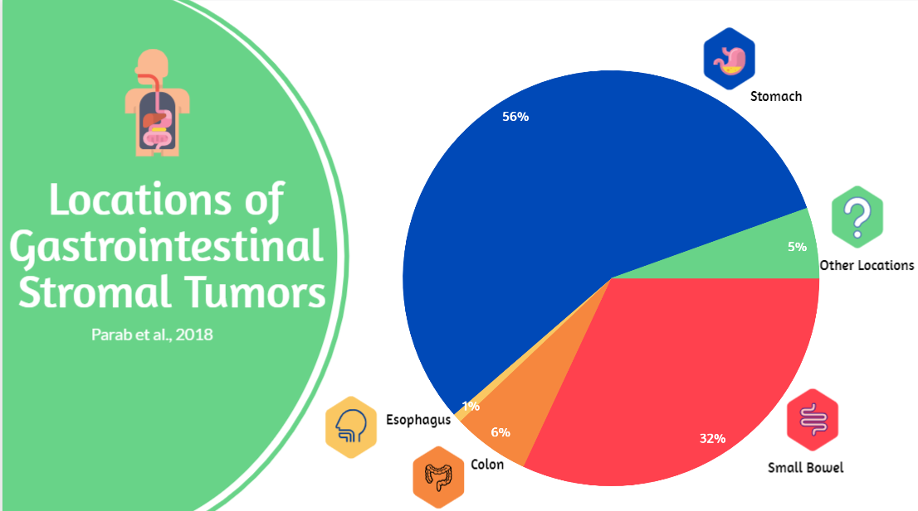

In the above graphic, it is easier to see that GISTs are most commonly found in the stomach and are least commonly found in the esophagus. For my father’s specific case, his GIST was found within the curve of the stomach that attaches to the end of the esophagus. However, a GIST is not just diagnosed based on finding a mass in one of these locations within the gastrointestinal tract, doctors also have to determine the mass’s histopathology and immunochemistry.

With this in mind, I then took the data provided by Parab et al. on histopathology to create another visualization to convey another common characteristic of a GIST. The below graphic demonstrates the various types of cells commonly found within a mass suspected to be a gastrointestinal stromal tumor. GISTs, according to Parab et al., have only three histologic findings, including spindle (70%), epithelioid (20%), or mixed type (10%), (Parab et al., 2018).

5

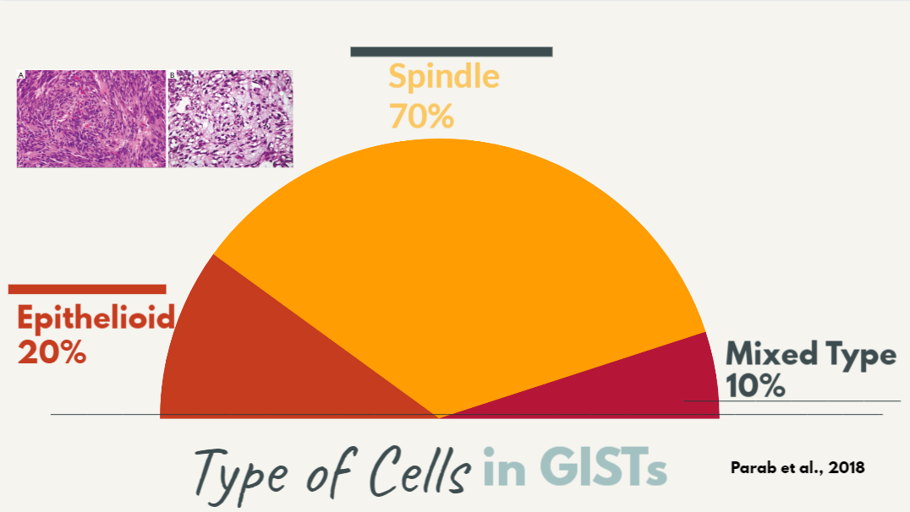

With this graphic it is more evident to viewers that GISTs most commonly feature just spindle cells and least commonly feature a mixture of cells within the tumor. My father’s tumor happened to include only spindle cells according to pathology. Though, as previously mentioned, the tumor’s immunochemistry is another indicator to pathologists and gastrointestinal doctors that a mass is truly a GIST.

Through a previously conducted trial, Parab et al. was able to get more specific estimates for the immunochemistry of a GIST by examining the genotypes found within tumors and their respective prevalence in GIST cases. Most GIST cases tend to have a CD117 genotype mutation expressed, but there are a few cases that either have a PDGFRA genotype mutation or no genotype mutations. The graphic below features the percentage of cases with each genotype mutation, based upon the trial discussed in Parab et al..

6

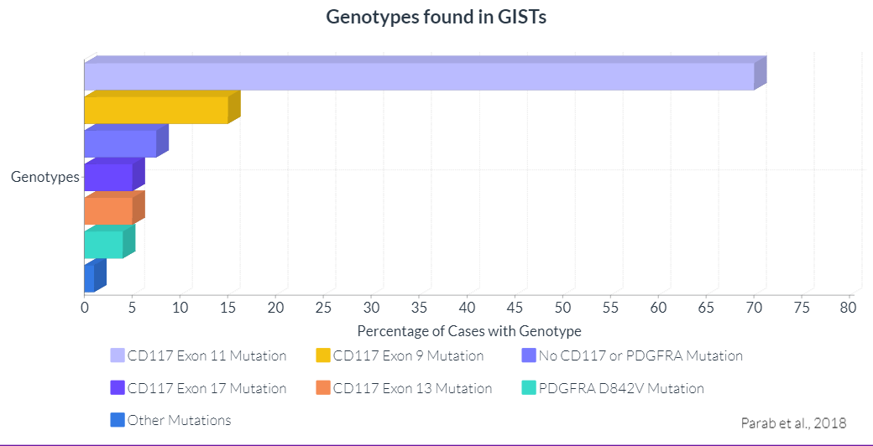

The above graphic depicts the CD117 Exon 11 mutation as the most common type of genotype found within a GIST, as this mutation is prevalent in about 70% of cases, (Parab et al., 2018). The rest of the genotypes found within a GIST and as depicted above are as follows: the CD117 Exon 9 mutation is found in 15% of cases; no CD117 or PDGFRA mutations are found in 5-10% of cases (rounded to 7.5 in the chart to reflect the median); less than 5% of cases feature either the CD117 Exon 17 mutation or the CD117 Exon 13 mutation, respectively; 4% of cases have the PDGFRA D842V mutation present; and finally, about 1% of cases feature other mutations, (Parab et al., 2018). The pathology conducted on my father’s GIST concluded that the tumor stained positive for a CD117 mutation, but due to the limited sample size, was unable to determine the specific CD117 exon mutation expressed.

Once a mass's location, histopathology, and immunochemistry are all definitively found, a gastroenterologist can collectively combine all the results to officially diagnose a patient with a confirmed GIST. From there, a doctor will assess the patient’s test results and will compare them

7

to the 2008, modified National Institute of Health’s (NIH) chart on risk classification to assign the patient to a risk group. A patient is assigned to a risk group based on the likelihood of tumor malignancy. The risk groups are as follows: very low risk, low risk, intermediate risk, and high risk. The below table is the modified NIH risk of recurrence chart that is featured in the Parab et al. (2018) article. No personal edits were made to the table, I simply placed the table below to serve as a reference.

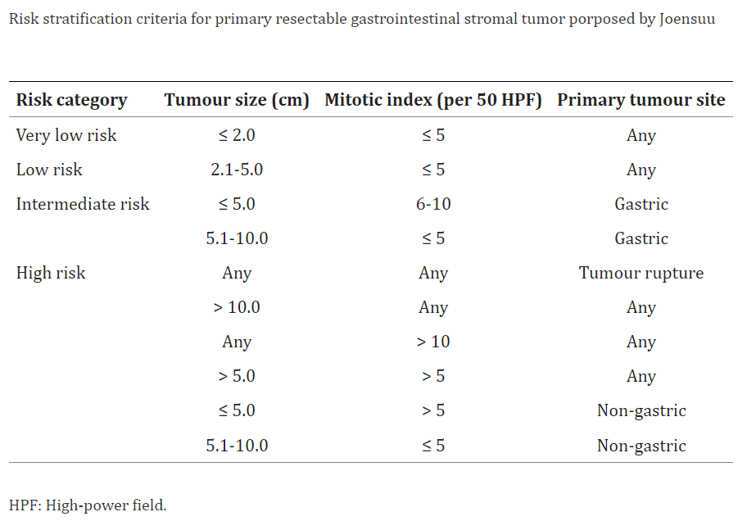

As you can see in the table above, a patient’s risk assessment is determined by the size of the tumor’s size, the mitotic rate of the cells within the tumor, and the primary location of the tumor (i.e., where the original tumor was first located). In my father’s case, he was placed in the very low risk category because his tumor was less than 2 centimeters in size, had little to no mitotic

8

activity in the cells, and was located within the stomach. A patient’s risk assessment helps determine a patient’s process of treatment and overall prognosis. The next section discusses various treatment methods for GISTs and features visuals for the treatment process after diagnosis.

**Treatments and the Treatment Process**

In another 2018 article, *Current Clinical Management of Gastrointestinal Stromal Tumor*, Akahoshi et al. acknowledges that “GISTs are not classified as either benign or malignant but are rather stratified by their clinical risk of malignancy,” (Akahoshi et al., 2018). With GISTs that are fairly contained, with a very low risk of metastasizing, surgery is the primary form of treatment and management, (Akahoshi et. al, 2018). However, with GISTs that either cannot be removed by surgery, already have metastasized, or are recurring, the primary form of treatment is the prescribing and use of tyrosine kinase inhibitors (TKIs), (Akahoshi et al., 2018). There are three primary TKIs utilized by doctors for GISTs depending on the level of advancement: imatinib, sunitinib, and regorafenib, (Akahoshi et al., 2018). More recent articles, such as *The Management of Metastatic GIST: Current Standard and Investigational Therapeutics* by Kelly et al. (2020) or *An Updated Review of the Treatment Landscape for Advanced Gastrointestinal Stromal Tumors* by Patel and Reichardt (2021), however, mention two other TKIs that were recently FDA approved- ripretinib and avapritinib- and a growing imatinib resistance in patients (Kelly et al., 2020), while also discussing other investigational therapeutic strategies for advanced GISTs (Patel and Reichardt, 2021). Overall though, the consensus on preferred GIST treatment strategy throughout the medical community, for the best reliability and curability, is- early histologic diagnosis and surgical removal while the disease is small and localized.

9

Depending on all of the results the doctor receives, the treatment process for a patient diagnosed with a GIST can greatly differ. In the 2018 article, *Gastrointestinal Stromal Tumors: A Multidisciplinary Challenge*, authors Sanchez-Hidalgo et al. crafted a flowchart diagram depicting the management of a gastrointestinal tumor after initial diagnosis, (Sanchez-Hidalgo et al., 2018). To best utilize the information provided in the diagram for my report, I edited and reformatted the chart into the visual seen below.

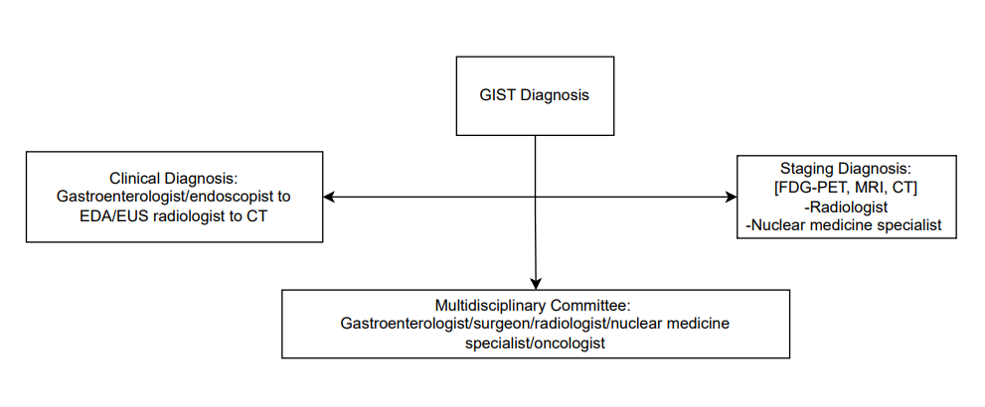

I adapted the flowchart because I decided to draft my own diagram based on my father’s GIST management process so far, in order to compare and contrast the two. The reason the above adaptation only features four boxes, though, is because my father has only completed the GIST diagnosis stage by receiving a clinical diagnosis, a staging diagnosis, and by meeting with a multidisciplinary committee. The process to get through each respective box and receive an actual GIST diagnosis featured several steps and a lot of time that is not pictured in the above diagram. The outline of my father’s treatment process thus far can be seen in the visualization below.

10

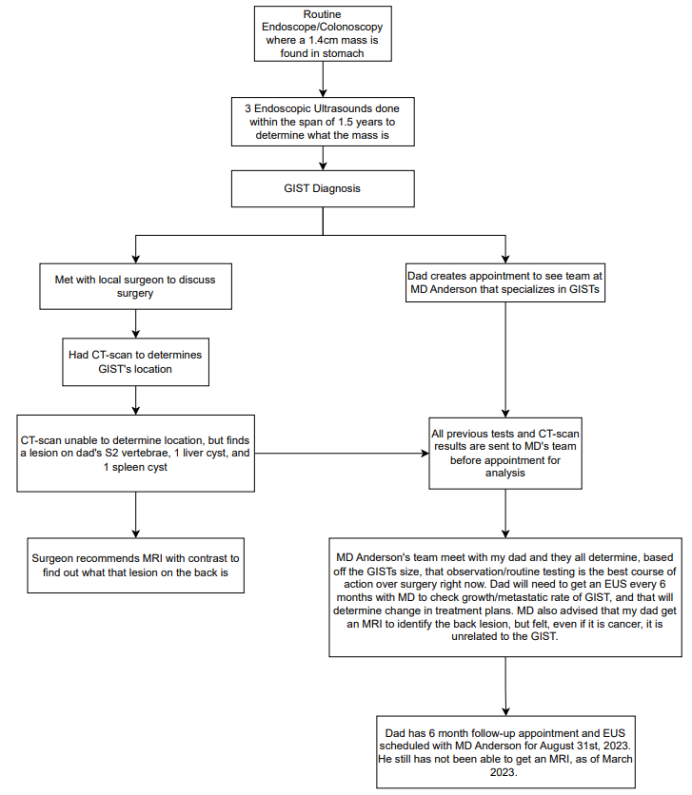

11

As you can see in the above diagram, it took approximately three endoscopic ultrasound procedures and one and a half years of waiting before my father was officially diagnosed with a GIST, and that was all after the unknown mass was found in his routine, 50-year colonoscopy and endoscopy. Then my father proceeded to follow two different pathways, one in which he met with a local surgeon to discuss treatment options, and the other where he met with the multidisciplinary, sarcoma team at M.D. Anderson in Houston. It was only after meeting with both the local surgeon and the Anderson team that my father was able to make the decision to continue receiving bi-annual care from the M.D. Anderson team in the form of endoscopic ultrasounds. Currently, since my father is deemed a low risk in terms of malignancy, M.D. Anderson's team believes that the observation path is the best and least harmful way to proceed with care. Comparing the research I have done thus far to my father’s particular case, I have begun to realize that there is no definitive treatment pathway or prognosis for a patient diagnosed with a gastrointestinal stromal tumor. In fact, this is particularly evident in the cases where the GIST begins to metastasize.

**Metastation of GISTs**

Although relatively rare, as only “about 10% to 30% of GISTs progress to malignancy,” in the most severe and high risk cases, GISTs can metastasize around the body, (Parab et al., 2018). A gastrointestinal stromal tumor originally found outside the stomach has a greater chance of metastasizing than a GIST found within the stomach. According to Parab et al. (2018), the most common locations for metastation are: the liver (28%), the mesentery and omentum (30%), the lungs (7%), subcutaneous tissue (4.7%), lymph nodes (4.7%), or bone (2.3%). The below visualization expresses this data in a barchart.

12

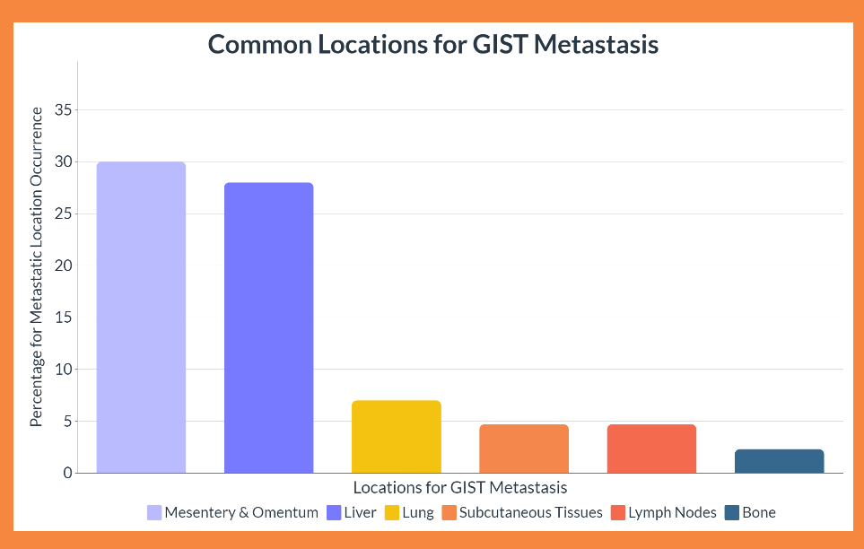

As seen in the above graphic, the most common place for a GIST to metastasize is the mesentery and omentum, while the least common place for a GIST to metastasize is within a bone. In a computerized tomography (CT) scan that my father had done recently to see the exact location of his GIST, the radiologist found a cyst on his liver and one on his spleen, while also finding an unknown lesion on his S2 vertebrae in his spine. Though the team at M.D. Anderson assured us that the cysts and the lesion are most likely non-cancerous and unrelated to his GIST, even if either or both prove to be cancerous later on, we were still encouraged to have my father complete a magnetic resonance imaging (MRI) scan with contrast to be sure. My father has yet to complete the MRI scan, but a diagnosis of a metastatic GIST would greatly change his treatment pathway and prognosis. As previously, briefly mentioned in a prior section, malignant

13

GISTs have started to become resistant to some tyronase kinetic inhibitors, causing medical professionals to turn to and develop other treatment therapies.

**Novel Therapeutic Strategies**

Eventually, 50% of GIST patients develop an imatinib resistance after using the TKI for about two years, (Vallilas et al., 2020). In particular, patients who happen to have the CD117 mutations with Exons 9, 11, 13, 14, or 17 have a raised resistance to imatinib compared to GIST patients with other mutations, (Vallilas et al., 2020). According to Vallilas et al. (2020), “recent studies have shown that ligands from the fibroblast growth factors (FGF) family reduce imatinib’s effect on GIST cells,” and FGF1 and FGF2 are seen heavily in GISTs. The development of FGF inhibitors may introduce a new therapy for fighting imatinib resistance and, subsequently, improving the overall prognosis of GIST patients, (Vallilas et al., 2020).

In their literary research, Vallilas et al. (2020) found that there are currently 313 active clinical trials for GISTs, where over 86 molecules are being studied to find new effective treatment therapies. Eight of those 313 trials are using immunotherapeutic agents, a therapy that has already shown impressive results in fighting other types of cancers, such as lung, renal, and melanoma, (Vallilas et al., 2020). Immunotherapies are a promising answer to fighting all cancers, and there are currently 17 future GIST trials planned that will utilize immunotherapy for further research. Though, there does seem to still be a debate amongst the medical community about the best method for treating GISTs and cancer as a whole. Some suggest that a combination of TKIs is the best method for improving the outcome of GISTs, while other researchers suggest liquid biopsies as a personalized way to monitor imatinib resistance and TKI treatment response, (Vallilas et al., 2020).

14

If medical professionals can agree on anything regarding GIST treatments, however, it is that combination therapies seem to currently be the most effective treatment plan. The combination of new immunotherapies, TKIs, and small molecules may be the key to inhibiting the molecular pathways that allow GIST cells to multiply. Overall, it seems like there needs to be even more clinical trials and research studies done to understand the complex molecular pathways of GISTs, in order to form a treatment therapy that effectively treats and diminishes the tumors.

**Conclusion**

Though there may be many reasons as to why obtaining a prognosis and effective treatment plan for GISTs could prove difficult, my research illuminates the lack of consensus and substantial research on the subject, within the medical community, as part of the cause. The study by Parab et al. allowed me to gain understanding of the fundamentals of a GIST, while also providing me with basic data points I could turn into visualizations for my report. In the study by Sanchez-Hidalgo et al., the flowchart the authors had drafted for treatment pathways after GIST diagnosis differed from the experience my father has had thus far in his own treatment and gave me the idea to include his story throughout my report.

From further research, I began to realize that the reason my father’s treatment process did not match up with the flowchart provided in Sanchez-Hidalgo et al. could be due to a variety of reasons. Apparently, there are countless mutations that a GIST could possess and these different mutations all have various known reactions with the tyrosine kinase inhibitors prescribed to patients if surgery is not a feasible option or a complete cure for a patient’s tumor. Some patients even develop a resistance to common TKIs, and the reason for this developed resistance is not currently well understood by researchers. Though there was not any raw or extensive data about

15

these TKIs included in any of the articles I was able to find, other than the names of the drugs, I was still able to include their importance in my report.

Going forward, as more research and clinical trials are conducted, hopefully new TKIs, molecules, and immunotherapies are found to aid in the fight against advanced GISTs. It should be considered in future research, however, how the combination of two or more of these things work together to combat GIST cell multiplication, as it has already been established that a combination of therapies is the most effective way to treat advanced GISTs. Also, future analyses should discuss and delve deeper into the treatment options of patients with smaller GISTs, who may not be eligible for surgery or TKIs yet, but still have a cancerous tumor potentially growing within their abdominal tract.

This topic was deeply personal to me to begin with because of my father, but my curiosity and interest only continued to grow the more I researched and learned about my topic. Although my research did not test my capabilities when it came to adapting and analyzing substantial datasets, I felt as though I was still able to create appropriate, effective, and visually stimulating graphics for my report that showcased the data I did have access to perfectly. I will continue to research this topic in the future, and I am looking forward to all of the medical advancements yet to come. As of now, though, I can conclude that there is currently not enough research on GISTs as a whole, and there is also not enough awareness amongst the public about GISTs as a type of cancer.

16

**References**

Akahoshi, K., Oya, M., Koga, T., & Shiratsuchi, Y. (2018, June 22). *Current Clinical Management of Gastrointestinal Stromal Tumor*. National Library of Medicine. Retrieved April 21, 2023, from <https://www-ncbi-nlm-nih-gov.ezp.twu.edu/pmc/articles/PMC6048423/>

Kelly, C. M., Gutierrez Sainz, L., & Chi, P. (2021, January 5). *The Management of Metastatic GIST: Current Standard and Investigational Therapeutics*. Journal of Hematology & Oncology. Retrieved April 21, 2023, from <https://www.ncbi.nlm.nih.gov/pmc/articles/PMC7786896/>

Mei, L., Du, W., Idowu, M., von Mehren, M., & Boikos, S. A. (2018, May 7). *Advances and Challenges on Management of Gastrointestinal Stromal Tumors*. Frontiers in Oncology. Retrieved April 21, 2023, from <https://www.ncbi.nlm.nih.gov/pmc/articles/PMC5949718/>

Patel, S. R., & Reichardt, P. (2021, July 1). *An Updated Review of the Treatment Landscape for Advanced Gastrointestinal Stromal Tumors*. Cancer. Retrieved April 21, 2023, from <https://www.ncbi.nlm.nih.gov/pmc/articles/PMC8252111/>

Parab, T. M., DeRogatis, M. J., Boaz, A. M., Grasso, S. A., Issack, P. S., Duarte, D. A., Urayeneza, O., Vahdat, S., Qiao, J.-H., & Hinika, G. S. (2018, August 7). *Gastrointestinal Stromal Tumors: A Comprehensive Review*. Journal of Gastrointestinal Oncology. Retrieved April 21, 2023, from <https://www-ncbi-nlm-nih-gov.ezp.twu.edu/pmc/articles/PMC6351301/>

17

Sanchez-Hidalgo, J. M., Duran-Martinez, M., Molero-Payan, R., Rufian-Peña, S., Arjona-Sanchez, A., Casado-Adam, A., Cosano-Alvarez, A., & Briceño-Delgado, J. (2018, May 14). *Gastrointestinal Stromal Tumors: A Multidisciplinary Challenge*. World Journal of Gastroenterology. Retrieved April 21, 2023, from <https://www.ncbi.nlm.nih.gov/pmc/articles/PMC5949708/>

Vallilas, C., Sarantis, P., Kyriazoglou, A., Koustas, E., Theocharis, S., Papavassiliou, A. G., & Karamouzis, M. V. (2021, January 22). *Gastrointestinal Stromal Tumors (GISTs): Novel Therapeutic Strategies with Immunotherapy and Small Molecules*. International Journal of Molecular Sciences. Retrieved April 21, 2023, from <https://www-ncbi-nlm-nih-gov.ezp.twu.edu/pmc/articles/PMC7825300/>